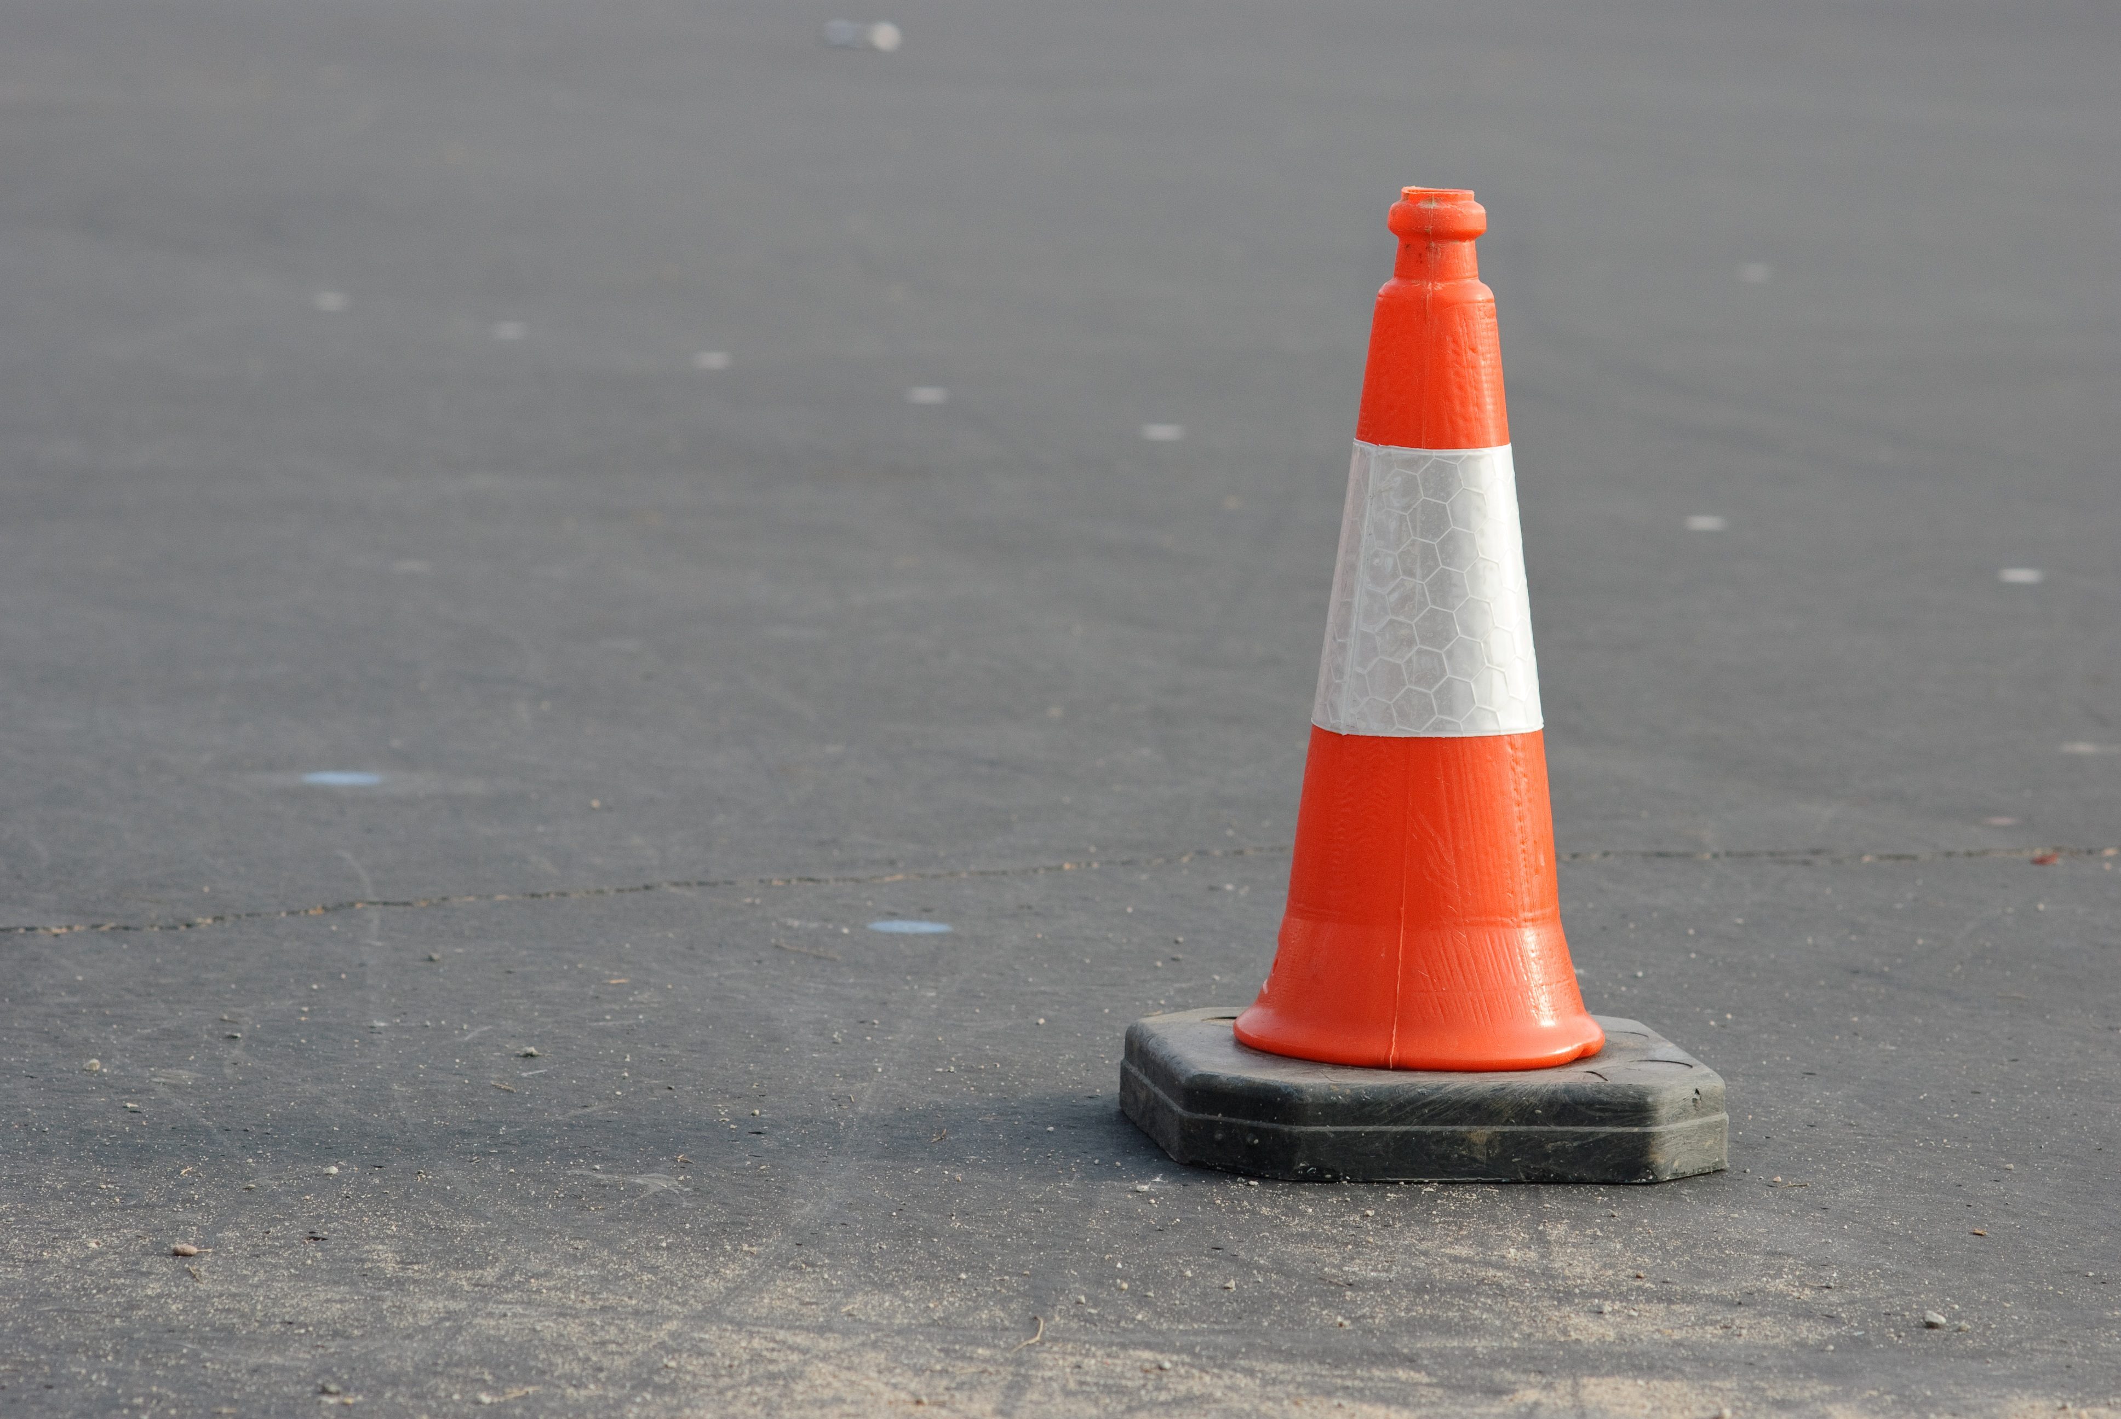
Under Construction – Check back with us soon!

